**ORB Test Automation SETUP GUIDE**

[Document subtitle]

[Date]

[Company address]



OBR preferred tool for automated testing is Selenium, an open-source solution, which we use in conjunction with Java. This setup integrates with a variety of dependencies, including TestNG, JUnit, WebDriverManager, and ITestResult, among others.

1. **Pre-Requisites:**

Use the below links to download tools and library’s (some might need elevated rights to download and install). Check you machine system settings or About for System type if its 64 or 32 bit before you begin download.

**IntelliJ** **(IDE -2021.1.3 )**:

<https://www.jetbrains.com/idea/download/#section=windows> (download the latest community edition)

[https://download.jetbrains.com/idea/ideaIC-2021.1.3.exe?_gl=1*1ldklnz*_ga*ODA3MDcxMTAxLjE2OTM0MDQ5MDM.*_ga_9J976DJZ68*MTcwMTk2MjE3Mi40LjEuMTcwMTk2MjI2My41MS4wLjA.&_ga=2.88233311.535361330.1701962172-807071101.1693404903](https://download.jetbrains.com/idea/ideaIC-2021.1.3.exe?_gl=1*1ldklnz*_ga*ODA3MDcxMTAxLjE2OTM0MDQ5MDM.*_ga_9J976DJZ68*MTcwMTk2MjE3Mi40LjEuMTcwMTk2MjI2My41MS4wLjA.&_ga=2.88233311.535361330.1701962172-807071101.1693404903)

* Open IntelliJ IDEA and configure the project SDK.
  + Navigate to "File" -> "Project Structure" -> "Project" and set the Project SDK to the installed JDK.
  + Configuring File Encoding as “UTF-8”

**Java JDK 17.0.6**:

* <https://www.oracle.com/ca-en/java/technologies/javase/javase-jdk8-downloads.html>
* Once java is installed verify by using java -version cmd in the command prompt app if no error.
* Copy the JDK folder path and create a System Variable under Environment Variable as JAVA_HOME

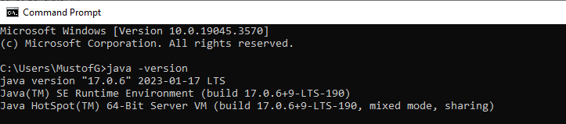

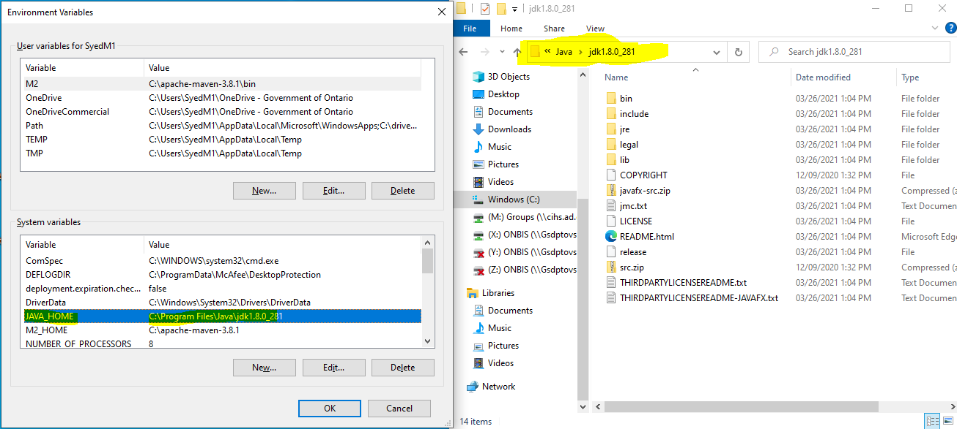

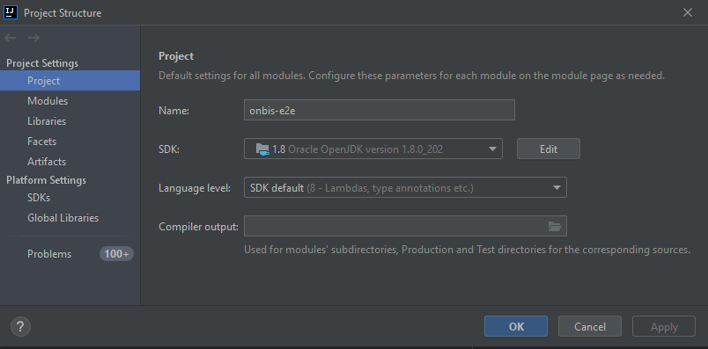

**Chrome Driver (Optional)**:

* <https://chromedriver.chromium.org/downloads> (download the version that matched your local chrome browser version)
* Download above library and save it in a new local ‘drivers’ folder under C drives; then set that folder as Path under System Properties/ Environment variables/User variable

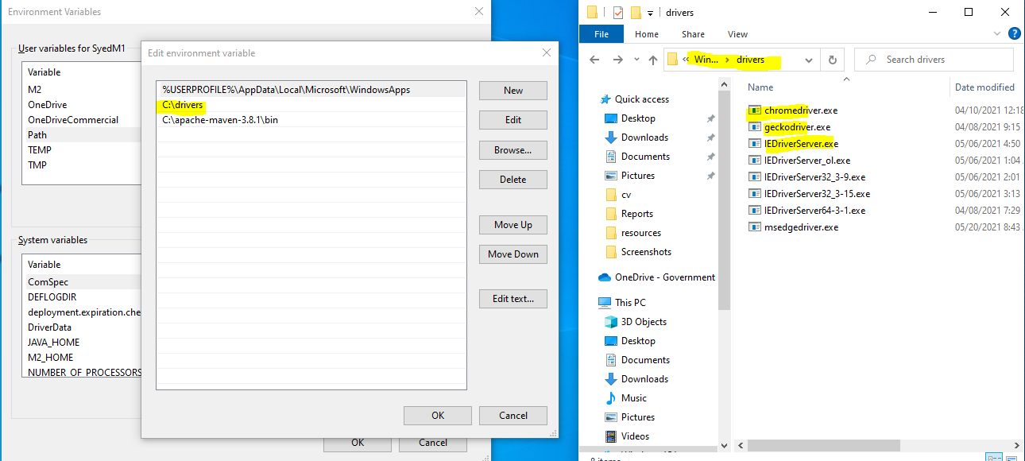

**Firefox Driver (Optional)**:

* <https://github.com/mozilla/geckodriver/releases>
* Download above library and save it in a new local ‘drivers’ folder under C drive; then set that folder as Path under System Properties/ Environment variables/User variable

**IE Driver (Optional):**

* <https://www.selenium.dev/downloads/>
* Download above library and save it in a new local ‘drivers’ folder under C drive; then set that folder as Path under System Properties/ Environment variables/User variable
* Copy the path of this library where it is download into and paste this path in the BaseTest.java class on line 32.

**Ruto Chrome extension:**

* <https://chrome.google.com/webstore/detail/ruto-xpath-finder/ilcoelkkcokgeeijnopjnolmmighnppp?hl=en>
* Download and install the above chrome extension (will need elevated access to download and install)

1. **Local Setup:**

* Download the project folder from shared directory (will be provided) or GitHub to local folder.
* Launch IntelliJ IDE and select Project from Existing Source.

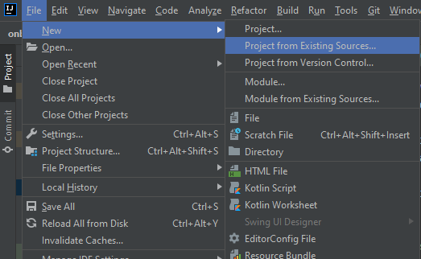

* Now select the above local folder and the project folder as for me it was under ‘C:\Workspace\onbis-e2e\' Then click OK.
* Select Import project option as ‘Import project from External module’ and Gradle. Then Finish

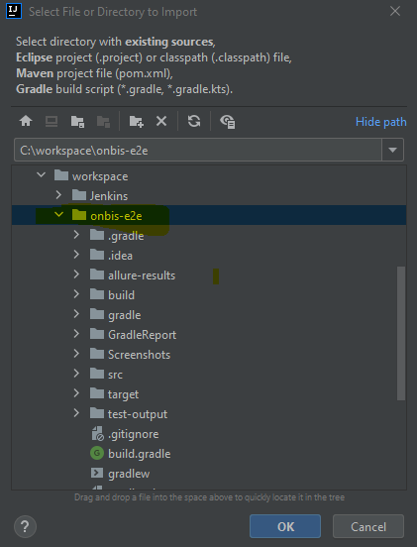

* Now Select Gradle tab on the right side, then click on Reload icon ‘Reload All Gradle Projects’, at the bottom it will start downloading all project dependencies/ indexing, once done success message is displayed under the Build tab.

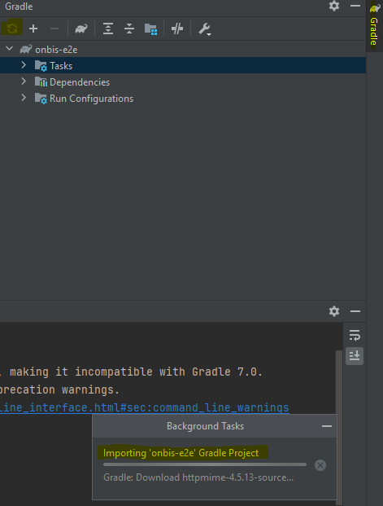

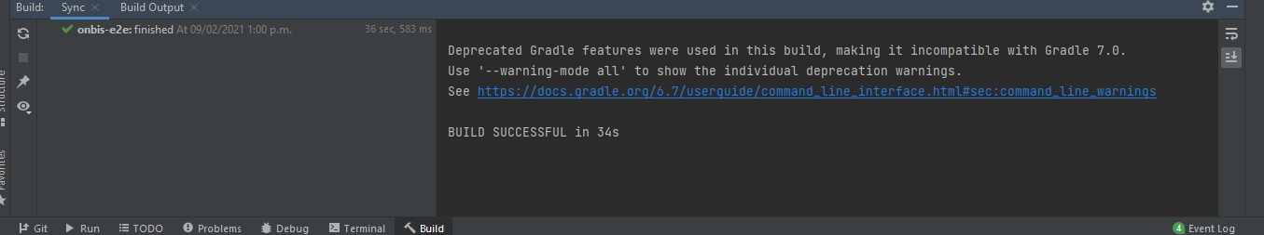

1. **Remote/Local Setup:**

* Use github repo URL (https://github.com/onbistestautomation/onbis-e2e)
* Navigate to IntelliJ IDE and select option Get from Version Control; Select Version Control as Git, Provide the above URL in the URL path and select local folder then click Clone (make sure to install Git if prompted).
* Provide the login credentials for bitbucket ([onbistestautomation@gmail.com/](mailto:mazher.syed2@ontario.ca/) TestAuto123!)when requested.
* Once cloned perform the above similar step to reload and download dependencies.
* Then follow the steps for test run configuration.
  + In order to run tests using FM-Dev2 or SO-Dev branch, you will need to switch branch from the bottom right of the IDE and then select checkout in the IDE and run using Dev run configuration that was created above in the run configuration.

**Note:**

Any time switching the branch you will have to commit(if you are sure of the changes) or rollback(to previous changes) the changes made

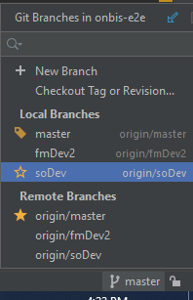

1. **Test Run Config:**

* Now select Run Menu Option. Then Edit Configuration. In the Run Configuration, select TestNG under Add New configuration. Then update the name, Suite and Environment Variable as attached text file and example below:



**Name**: UAT

**Suite**: local path to the testng.xml file (can browser it)

**Environment Variables**: (copy below text and place it for UAT)

ENV=UAT;epfUrl=https://www.pss.gsa.gov.on.ca/AuthenticateUserLocalEPF.html;MyAccount=https://stage.www.appmybizaccount.gov.on.ca/wps85/myportal/osb/myactivity?iframe\\=true&lang\\=en;oneKeyPassword=TestAuto123!;OneKeyUrl=https://stage.one-key.gov.on.ca/iaalogin/IAALogin.jsp?;oneKeyUserName=soabAutoUAT4540;osbServiceCatalog=https://stage.www.appmybizaccount.gov.on.ca/wps85/osb/public/POC/OSB-Ontario-ca-ServiceCatalog.html;PartnerPortalDashboard=https://stage.gssso.sus.gov.on.ca/onbis/partner/launcher;partnerPortalPassword=ReTestAuto123!;PartnerPortalUrl=https://stage.gssso.sus.gov.on.ca/onbis/partner;partnerPortalUserName=onbistestautomation@gmail.com;pkiPassword=Ps1sCatalyst;SOAdminPortal=https://intra.stage.gssso.sus.gov.on.ca/onbis/admin;soAdminWelcome=https://stage.intra.services.gov.on.ca/wps85/myportal/soadmin/adminhome/welcome/;soAdminWelcomeDev=https://intradev.services.ebc.gov.on.ca/wps85/myportal/soadmin/adminhome/welcome/;soabPortalPassword=ReTestAuto123!

* Then click Apply.

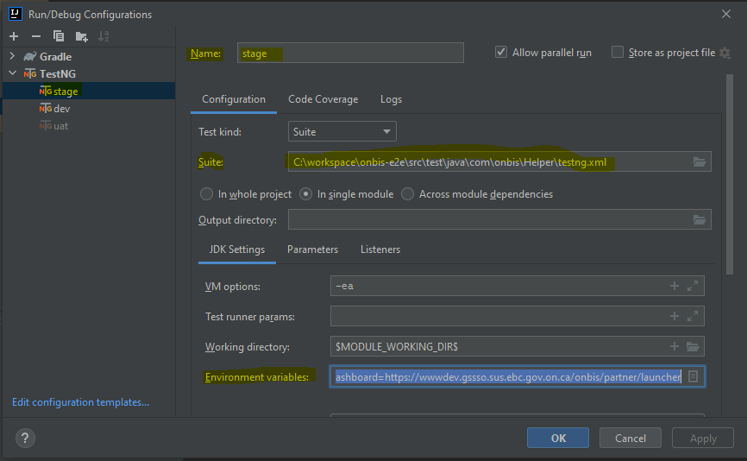

* Do the above run configuration steps for UAT, Dev, FM-UAT2, FM-Dev2, FM-Stage2 and Save it with the below Name and Environment variables.

**Name**: Uat2

**Environment variables:** (copy below text for UAT2)

ENV=UAT2;epfUrl=https://www.pss.gsa.gov.on.ca/AuthenticateUserLocalEPF.html;MyAccount=https://stage.www.appmybizaccount.gov.on.ca/wps85/myportal/osb/myactivity?iframe\\=true&lang\=en;oneKeyPassword=ReTestAuto123!;OneKeyUrl=https://stage.one-key.gov.on.ca/iaalogin/IAALogin.jsp?;oneKeyUserName=soabAutoUAT28470;osbServiceCatalog=https://stage.www.appmybizaccount.gov.on.ca/wps85/osb/public/POC/OSB-Ontario-ca-ServiceCatalog.html;PartnerPortalDashboard=https://stage.gssso.sus.gov.on.ca/onbis/partner/launcher;partnerPortalPassword=ReTestAuto123!;PartnerPortalUrl=https://stage.gssso.sus.gov.on.ca/onbis/partner;partnerPortalUserName=onbistestautomation@gmail.com;pkiPassword=Ps1sCatalyst;SOAdminPortal=https://intra.stage.gssso.sus.gov.on.ca/onbis/admin;soabPortalPassword=ReTestAuto123!

**Name**: Stage

**Environment variables:** (copy below text for Stage)

ENV=Stage;epfUrl=https://www.pss.gsa.gov.on.ca/AuthenticateUserLocalEPF.html;MyAccount=https://wwwstage.appmybizaccount.ebc.gov.on.ca/wps85/myportal/osb/;oneKeyPassword=TestAuto123!;OneKeyUrl=https://stage.one-key.gov.on.ca/iaalogin/IAALogin.jsp?;oneKeyUserName=soabAutoStage5222;osbServiceCatalog=https://wwwstage.appmybizaccount.ebc.gov.on.ca/wps85/osb/public/POC/OSB-Ontario-ca-ServiceCatalog.html;PartnerPortalDashboard=https://wwwstage.gssso.sus.ebc.gov.on.ca/onbis/partner/launcher;partnerPortalPassword=ReTestAuto123!;PartnerPortalUrl=https://wwwstage.gssso.sus.ebc.gov.on.ca/onbis/partner;partnerPortalUserName=onbistestautomation@gmail.com;pkiPassword=Ps1sCatalyst;SOAdminPortal=https://intrastage.gssso.sus.ebc.gov.on.ca/onbis/admin;soAdminWelcome=https://intrastage.services.ebc.gov.on.ca/wps85/myportal/soadmin/adminhome/welcome/;soAdminWelcomeDev=https://intradev.services.ebc.gov.on.ca/wps85/myportal/soadmin/adminhome/welcome/;soabPortalPassword=ReTestAuto123!

**Name**: Stage2

**Environment variables:** (copy below text for Stage2)

ENV=Stage2;epfUrl=https://www.pss.gsa.gov.on.ca/AuthenticateUserLocalEPF.html;fm2PartnerPortalDashboard=https://wwwstage.gssso.sus.ebc.gov.on.ca/onbis/partner/launcher?env=obr2;MyAccount=https://stage.www.appmybizaccount.gov.on.ca/wps85/myportal/osb/myactivity?iframe\\=true&lang\\=en;oneKeyPassword=TestAuto123!;OneKeyUrl=https://stage.one-key.gov.on.ca/iaalogin/IAALogin.jsp?;oneKeyUserName=soabAutoStage29677;osbServiceCatalog=https://wwwstage.appmybizaccount.ebc.gov.on.ca/wps85/osb/public/POC/OSB-Ontario-ca-ServiceCatalog.html;PartnerPortalDashboard=https://stage.gssso.sus.gov.on.ca/onbis/partner/launcher;partnerPortalPassword=TestAuto123!;PartnerPortalUrl=https://wwwstage.gssso.sus.ebc.gov.on.ca/onbis/partner;partnerPortalUserName=onbistestautomation@gmail.com;pkiPassword=Ps1sCatalyst;RegistryMainLaunch2URL=https://intrastage.services.ebc.gov.on.ca/wps85/myportal/soadmin/adminhome/welcome/!ut/p/z1/04_Sj9CPykssy0xPLMnMz0vMAfIjo8zivT19DNw93A38_EMcXQwcw_w8Q0wdvQ0N3E30wwkpiAJKG-AAjgZA_VFgJbhMMDCDKsBjRkFuhEGmo6IiABGfaQI!/dz/d5/L2dBISEvZ0FBIS9nQSEh/?uri=nm:oid:Z6_6OG0IBG0N8ND00QHIM0PKB30K0;soAdminEnvironmentURL=https://intrastage.services.ebc.gov.on.ca/wps85/myportal/soadmin/adminhome/onbis/launch2/;SOAdminPortal=https://intratest.obr.ebc.gov.on.ca/onbis/admin;soAdminWelcome=https://intrastage.services.ebc.gov.on.ca/wps85/myportal/soadmin/adminhome/welcome/;soAdminWelcomeDev=https://intradev.services.ebc.gov.on.ca/wps85/myportal/soadmin/adminhome/welcome/;soabPortalPassword=ReTestAuto123!

**Name**: BAT

**Environment variables:** (copy below text for BAT)

OneKeyUrl=https://stage.one-key.gov.on.ca/iaalogin/IAALogin.jsp?;oneKeyUserName=soabAutoUAT23914;oneKeyPassword=TestAuto123!;MyAccount=https://stage.www.appmybizaccount.gov.on.ca/wps85/myportal/osb/myactivity?iframe\\=true&lang\=en;PartnerPortalUrl=https://stage.gssso.sus.gov.on.ca/onbis/partner;partnerPortalUserName=onbistestautomation@gmail.com;partnerPortalPassword=TestAuto123!!;PartnerPortalDashboard=https://stage.gssso.sus.gov.on.ca/onbis/partner/launcher;epfUrl=https://www.pss.gsa.gov.on.ca/AuthenticateUserLocalEPF.html;pkiPassword=Ps1sCatalyst;osbServiceCatalog=https://stage.www.appmybizaccount.gov.on.ca/wps85/osb/public/POC/OSB-Ontario-ca-ServiceCatalog.html;SOAdminPortal=https://intra.stage.gssso.sus.gov.on.ca/onbis/admin;BAT_Url=https://bat.onbis.project.fostermoore.com/onbis/driver/;ENV=BAT

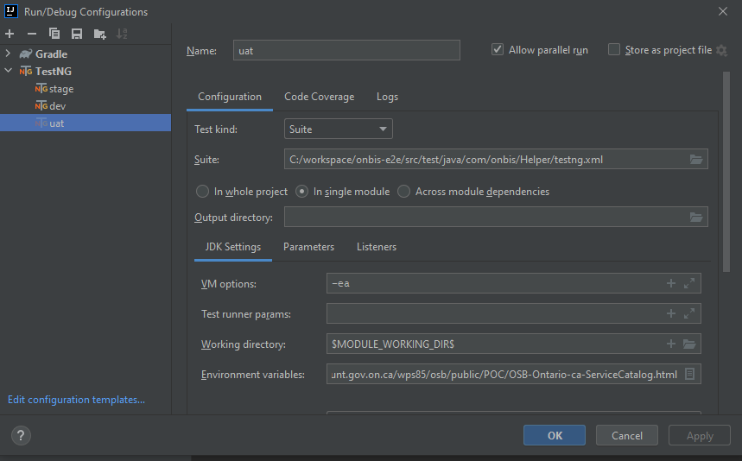

**Note:**

After refreshing the OBR database, users may require manual activation through the receipt of an Activation Code. Kindly adhere to the provided guidelines for the activation process.



Please note that our automation scripts for OBR are specifically designed and executed exclusively in the Chrome browser on Windows 10 Professional. This approach is intentional as our testing focus does not extend to cross-browser and cross-platform scenarios.

**Gmail API- Authorization- Setup:**

-On the first test run, you will have to authorize the [onbistestautomation@gmail.com](mailto:onbistestautomation@gmail.com) account in the browser that will launch, if not use the URL form the console.

To set up authorization for Gmail API in a Selenium environment, you can follow these general steps. Note that specific implementation details may vary based on your programming language and tools used:

* **Create a Project in the Google Cloud Console:**
* Go to the Google Cloud Console.
* Create a new project or select an existing project.
* Enable the Gmail API for your project.
* Create OAuth 2.0 Credentials:
* **Navigate to the "Credentials" section in the Google Cloud Console.**
* Create credentials by selecting "OAuth client ID."
* Choose the application type (e.g., Web application).
* Set the authorized redirect URI to a callback URL in your Selenium application.
* Download the Credentials JSON File:
* **Download the JSON file containing your OAuth 2.0 credentials.**
* Keep this file secure, as it contains sensitive information under the directory:
  + onbis-e2e\src\main\resources\credentials
* Because of Google's and OPS's periodic security updates, there's a possibility that Gmail API authorization might be disrupted, leading to the failure of all our tests involving Gmail interactions. In such circumstances, kindly comment out Gmail validation within the scripts

**Manually copy following files within “onbis-e2e” directory if they don’t exist:**

* -VBS files







* -EXE files



* -AutoIT file



* Computer Registry Edit (Regedit) file



1. **Test Run Steps:**

* From the IDE select the run configuration created above (Stage or Uat)
* Now click on the green play icon, you should see IDE would build then start the tests

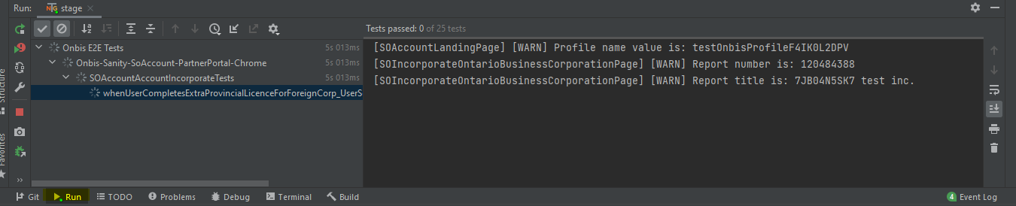

* If multiple tests need to be run in parallel under the run configuration you need to select ‘Allow parallel Run’ 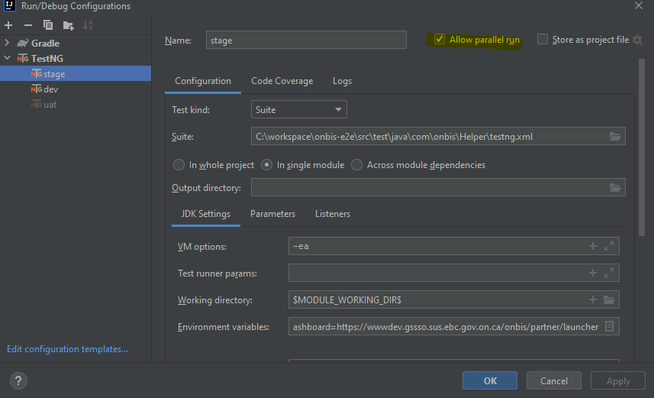
* -Anytime test fails, screenshot is automatically take and stored in the below path for debugging in onbis-e2e/Screenshots directory.

**Credentials:**

* + Gmail- Account:
  + onbistestautomation@gmail.com/ TestAuto123!
  + https://github.com/ - Account:
  + onbistestautomation@gmail.com/ TestAuto123!

1. **Reference:**

**Selenium WebDriver:**

<https://www.selenium.dev/documentation/webdriver/>

**TestNG:**

<https://testng.org/doc/documentation-main.html>

**Gmail API:**

<https://developers.google.com/gmail/api/quickstart/java>